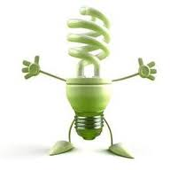
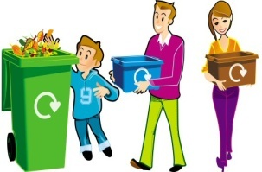
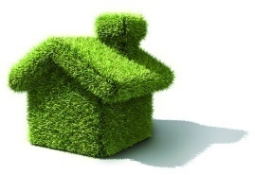
In order to achieve a world really durable, we are going to give you a few pieces of advice, which will help us in our fight against the
destruction of the planet.
reduction of the climate change effects on our planet

Did you know that the climate changes are caused by the increase in CO₂ emissions in the atmosphere come from burning fossil fuels?

AT HOME
WASTE MANAGING
The Earth’s global warming is mostly triggered by the emissions resulted from human activity.
The ”Reduce, Reuse, Recycle – with joy of learning” project proposes to promote actions of
environmental protection within our
community.



Did you know that waste
burning and its burial in especially designed places leads to gas
evacuation with greenhouse effects?

One of the
approached themes
is the necessity to put
into practice local
actions which have
as an output the


• Diminish the amount of useless
package;
• When you purchase a product,
make sure that it is packed in glass, tin, plastic and last of all in tetrabrick, which is the most difficult material
to recycle, as it contains cardboard,
plastic and aluminium;
• Use biodegradable bags when
shopping;
• Sort and separate waste items.
Keep them in adequate bins;
• Keep dangerous waste in specially
arranged places. They could be: old
batteries, appliances using Freon,
electric discharge lamps, a.s.o.

REDUCE WASTE IMPACT
ON THE PLANET

• Turn off appliances if they are not
used;
• Do thermal insulation to your house;
• Install thermal solar panels;
• Use bulbs with low consumption of
energy;
• Disconnect the TV set and the from
the power source;

Did you know that by saving water,
we save energy otherwise used for
transportation? Besides, the warm water production is also energy consuming.

• Use the shower when you wash your
self and avoid using the bathtub;
• Buy dishwashers that use a smaller
quantity of water than in the case of hand washing.



